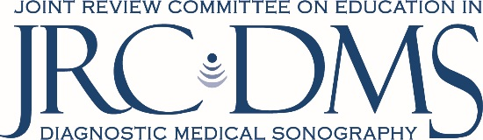

JRC-DMS Summary Curriculum Vitae Form

Name of Institution/Affiliate: Program Number:

Name (last, first, middle initial):

Work Telephone Number: Work Email Address:

NOTE: If the official name provided above does not match the name as listed with the credentialing organization, provide a copy of an appropriate legal document verifying the name change or name difference, i.e., a marriage certificate.

Job Title:

EDUCATION:
Begin with baccalaureate or other initial professional education and include postdoctoral training. Identify all post-high school education in chronological order:

Institution and location | Degree | Year conferred | Area of study

Indicate Professional Credential(s):
RDMS (AB) RDMS (BR) RDMS (OB) RDCS (AE) RDCS (PE) RMSKS
RCS RCCS RVT RVS RT(S)
For applicable registry(ies) the credential number(s) must be provided:
ARDMS Registry #: CCI Registry #: ARRT Registry #:

Primary areas of specialization:

Percent of Job Responsibilities (program directors only):

% Time Performing Administrative Duties

% Time Teaching /Student Interaction

% Time for Other Responsibilities
_________________________________________________
= 100% (Total must add up to 100%)

Describe how proficiency in curriculum development was obtained (program directors and concentration coordinators only):

Describe how proficiency in teaching methodologies* was obtained (clinical coordinators only):

Professional Development Table (program directors, concentration coordinators & clinical coordinators) List three faculty development sessions attended in the past two years:
Title | Sponsoring Organization | Month/Year

Do you meet the two-years of employed clinical experience?
Yes No If no, please explain:

List in reverse chronological order previous employment experience:

Employer | Employment Title | Specialty(ies) Practiced | Date Started | Date Ended

*Suggested resources to gain proficiency in teaching methodologies. Include certificate of completion if a course listed below is completed.
- Coursera offers a course entitled “Foundations of Teaching for Learning: Curriculum” https://www.coursera.org/learn/teacher-curriculum
- If the Clinical Coordinator is an SDMS member, there are two courses in the SDMS e-Learning Center entitled “Foundations of Curriculum Design” and Instructional Methodologies”

